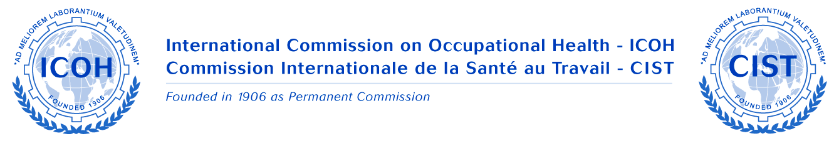

INTERNATIONAL COMMISSION ON OCCUPATIONAL HEALTH

SCIENTIFIC COMMITTEE ON
OCCUPATIONAL HEALTH IN SMALL SCALE ENTERPRISES AND THE INFORMAL SECTOR (SCOHSSEIS)

Minutes of Business Meeting at 31st ICOH Congress, Seoul, Korea
Monday 1st June 2015

Present: See attached list
Apologies: Dr Paula Naumanen, Professor Jaehoon Roh, Dr Sunil Joshi, Dr Edith Clarke

Chair: Mahinda Seneviratne (on behalf of Dr Naumanen)

- SC Report for 2012-15 triennium
Mahinda presented the triennium report (Powerpoint) prepared by Paula and Christina Gunnarsson, in their absence.

The Committee endorsed the report, thanked both for their useful work on the Executive and wished Christina well in her future activities.

Mahinda reported on the SC Chairs and Board meeting held on 30 May. Key message from that meeting was for
- more visible activity by each SC in the next triennium and
- increased collaboration between SCs and with relevant external partners

- Elections for 2015-2018 triennium
Paula Naumanen was re-elected as Chair
Mahinda Seneviratne was confirmed as new Secretary

Executive committee – expressions of interest were called to expand the SC Executive so that a better geographic balance and equity can be achieved, as per ICOH equity principles.

Prof Somnath Gangopadhyay and Dr Ashish Mittal (India) and Dr Edith Clarke (Ghana) expressed their interest. They will be nominated to join the Executive.

It was requested that: current members on the Executive please confirm in writing to the Chair if you wish to continue in the next triennium.

SC members particularly from the Americas, west Asia and from emerging economies in the eastern European region were requested to consider joining the Executive to improve its geographic composition, so that the SC can better serve those regions.

3. SCOHSSEIS members
  - The number had increased from 28 to 38 during the last triennium
  - Two new members joined the SC after the BM.

- Activities for 2015-2018 triennium
Three events already planned.
- USE 2015 at Groningen, Netherlands in October. Details are on ICOH website.
- ICOEH 2016 in New Delhi, India in February. Dr Mittal will write to the SC.
- USE 2017 in Colorado, USA in October. Dr Lee Newman (US NIOSH) is organising. It will be an opportunity for those from the Americas & Caribbean to be involved.

A number of ideas were put forward and discussed, keeping in mind the Board’s message and the specific challenges with SMEs and the Informal sectors. These were:
- Promote tool kits and guidance material with a primary preventive focus
- Action-oriented tools and training (contact Dr Kawakami – ILO)
- Compile success stories and database of good practice (suggestion by Dr Kogi)
- Disseminate SME guide available on ICOH website
- Workshops / Symposiums to build sector capabilities. Collaborate with other SCs and organisations. Ghana 2011 was a successful approach.
- Write articles on members’ activities and for journals

- Work Plan for 2015-2018 triennium with planned activities
The SC agreed that a Work Plan for the triennium should be developed from the ideas discussed and suggestions made.

Mahinda will provide a draft Work Plan through Paula for members’ comment and input. It will include:
- Planned activities: USE 2015, ICOEH 2016 and USE 2017
- Exploring potential activity in under-served regions
- Plans for ICOH Congress Dublin, Ireland 2018
- Collaborations with other SC and relevant organisations

- Other Business – no other business discussed.

